Monthly Time Record – Field Placement

Student Name:

Time Period From |  | To

Hrs. direct supervision:
AM PM by other
Total agency agency
Month Day In Out In Out In Out In Out Daily Hrs. Field Instr. staff
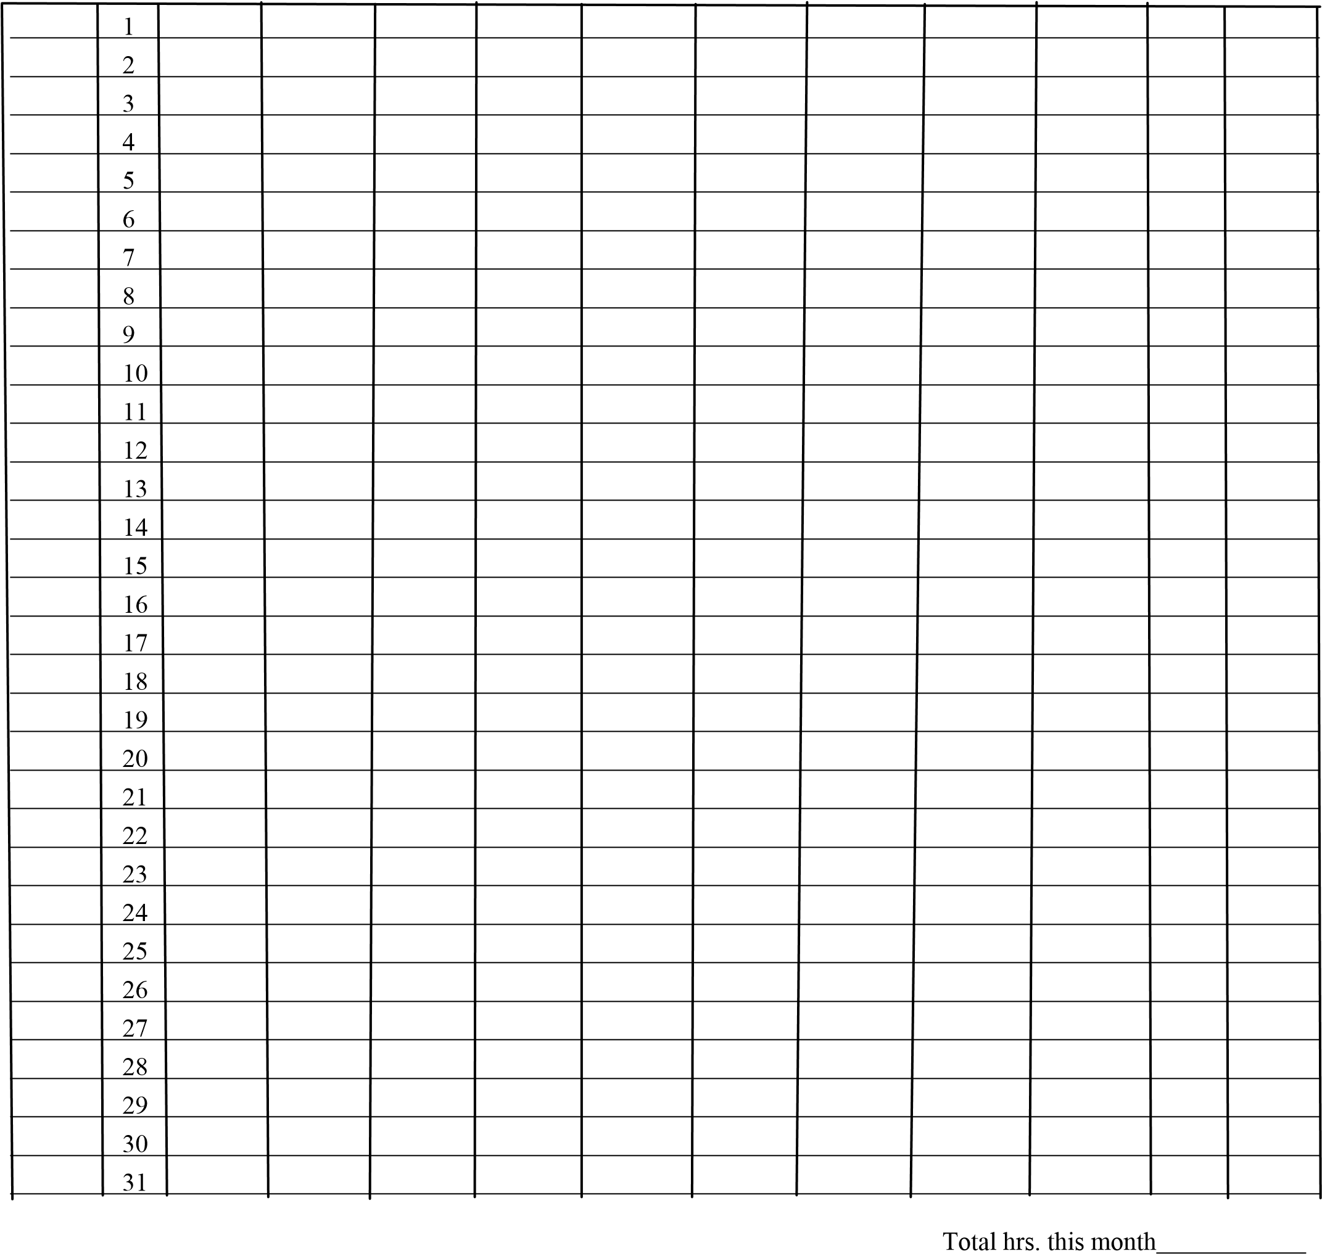
I certify this time to be correct ____________________________ Total hrs. to date ___________
Student’s Signature
I have reviewed this above time sheet and have found it to be accurate. Agency Field Instructor Signature

